Mahmoud

Requirements Gathering

Stakeholder Analysis
Identifying key stakeholders and their needs.

Stakeholder | Key Needs & Expectations
Marketing Department | Needs targeted lists of high-risk customers to design "win-back" campaigns and personalized offers.
Customer Success / Support | Requires real-time churn risk indicators during customer interactions to prioritize issue resolution.
Network Operations (NOC) | Needs to understand if technical failures (dropped calls, slow data) are driving customers away.
Executive Leadership (C-Suite) | Needs high-level KPIs, such as Monthly Churn Rate and Revenue Loss Projection, to make strategic decisions.
IT/Data Engineers | Need a stable, scalable, and automated pipeline that requires minimal manual intervention.

User Stories & Use Cases
Scenarios illustrating how users interact with the system.

2. User Stories & Use Cases
Scenarios illustrating how different users will benefit from the AI pipeline.

User Stories
- As a Marketing Manager, I want to filter customers by their "Churn Probability Score" so that I can allocate my retention budget to those most likely to leave.
- As a Data Scientist, I want an automated feature engineering pipeline so that I can spend more time tuning models rather than cleaning raw network logs.
- As a Business Analyst, I want an interactive dashboard that correlates network performance with churn trends to identify root causes.

Use Case: Automated Retention Trigger
- Primary Actor: Automated Data Pipeline / CRM System.
- Main Success Scenario:
  - The pipeline ingests daily technical and billing data.
  - The XGBoost model generates churn scores for all active subscribers.
  - Customers with a score $> 0.85$ are flagged.
  - The system pushes this list to the Marketing CRM via the FastAPI endpoint.
  - An automated retention offer (e.g., "50% off next month") is sent to the customer.

Functional Requirements
List of features and functionalities.

Specific features and behaviors the system must provide.
- FR1: Data Integration: The system shall integrate structured billing data from Huawei RDS and semi-structured network logs from Huawei OBS.
- FR2: Automated Preprocessing: The system must handle missing values, normalize numerical data, and encode categorical variables automatically.
- FR3: Churn Prediction: The model must output a probability score between $0$ and $1$ for every customer ID.
- FR4: Feature Importance: The system shall provide "explainability" by listing the top three factors contributing to each high-risk prediction.
- FR5: API Access: The system must provide a RESTful API to allow external applications to query the churn status of specific subscribers.
- FR6: Visualization: The Streamlit dashboard must display churn trends over time and geographical heatmaps of churn hot-spots.

Non-functional Requirements
Performance, security, usability, and reliability criteria

Criteria that define the system's operation and quality.
- Performance: The end-to-end batch processing (from ingestion to prediction) for 1 million records must be completed within 60 minutes.
- Scalability: The architecture must be cloud-native, allowing Huawei ECS and DWS to scale horizontally as data volume grows.
- Reliability: The pipeline shall include an automated retry mechanism and alert administrators via email/logs if a data ingestion task fails.
- Security: Personal Identifiable Information (PII) must be masked or encrypted. Access to the ModelArts environment and DWS must be restricted via Identity and Access Management (IAM) roles.
- Availability: The prediction API and Streamlit dashboard should maintain 99.9% uptime during business hours.
- Maintainability: All code must be version-controlled (e.g., Git) with documented Python scripts and SQL queries for future updates.

Omar's tab

Requirements Gathering

Stakeholder Analysis
Identifying key stakeholders and their needs.

Stakeholder | Key Needs & Expectations
Marketing Department
Customer Success / Support
Network Operations (NOC)
Executive Leadership (C-Suite)
IT/Data Engineers

2. User Stories & Use Cases
Scenarios illustrating how different users will benefit from the AI pipeline.

User Stories
- As a Marketing Manager, I want to filter customers by their "Churn Probability Score" so that I can allocate my retention budget to those most likely to leave.
- As a Data Scientist, I want an automated feature engineering pipeline so that I can spend more time tuning models rather than cleaning raw network logs.
- As a Business Analyst, I want an interactive dashboard that correlates network performance with churn trends to identify root causes.

Use Case: Automated Retention Trigger
- Primary Actor: Automated Data Pipeline / CRM System.
- Main Success Scenario:
  - The pipeline ingests daily technical and billing data.
  - The XGBoost model generates churn scores for all active subscribers.
  - Customers with a score $> 0.85$ are flagged.
  - The system pushes this list to the Marketing CRM via the FastAPI endpoint.
  - An automated retention offer (e.g., "50% off next month") is sent to the customer.

Functional Requirements
List of features and functionalities.

Specific features and behaviors the system must provide.
- FR1: Data Integration: The system shall integrate structured billing data from Huawei RDS and semi-structured network logs from Huawei OBS.
- FR2: Automated Preprocessing: The system must handle missing values, normalize numerical data, and encode categorical variables automatically.
- FR3: Churn Prediction: The model must output a probability score between $0$ and $1$ for every customer ID.
- FR4: Feature Importance: The system shall provide "explainability" by listing the top three factors contributing to each high-risk prediction.
- FR5: API Access: The system must provide a RESTful API to allow external applications to query the churn status of specific subscribers.
- FR6: Visualization: The Streamlit dashboard must display churn trends over time and geographical heatmaps of churn hot-spots.

Non-functional Requirements
Performance, security, usability, and reliability criteria

Criteria that define the system's operation and quality.
- Performance: The end-to-end batch processing (from ingestion to prediction) for 1 million records must be completed within 60 minutes.
- Scalability: The architecture must be cloud-native, allowing Huawei ECS and DWS to scale horizontally as data volume grows.
- Reliability: The pipeline shall include an automated retry mechanism and alert administrators via email/logs if a data ingestion task fails.
- Security: Personal Identifiable Information (PII) must be masked or encrypted. Access to the ModelArts environment and DWS must be restricted via Identity and Access Management (IAM) roles.
- Availability: The prediction API and Streamlit dashboard should maintain 99.9% uptime during business hours.
- Maintainability: All code must be version-controlled (e.g., Git) with documented Python scripts and SQL queries for future updates.

Recquirements
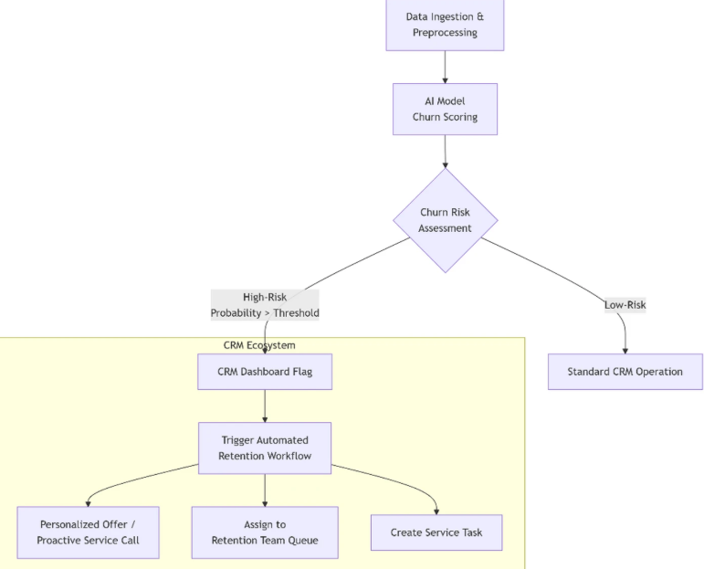

Datasets
- https://www.kaggle.com/datasets/zagarsuren/telecom-churn-dataset-ibm-watson-analytics

- Customer churn prediction in telecom sector
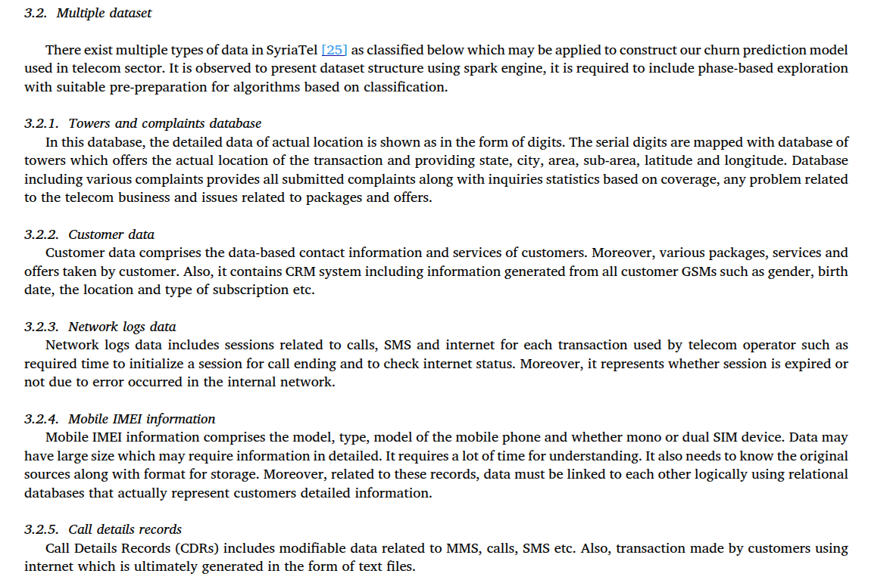

https://wiki.opencellid.org/wiki/Cells database_format

The file is updated on a daily basis and includes cell towers observed in the last 18 months
- Each token will be able to download only twice per day
- The database is licensed under a Creative Commons Attribution-ShareAlike 4.0 International License

Parameter | Data type | Description
<radio> | string | Network type. One of the strings GSM, UMTS, LTE or CDMA.
<mcc> | integer | Mobile Country Code, for example 260 for Poland.
<net> | integer | For GSM, UMTS and LTE networks, this is the Mobile Network Code (MNC).  For CDMA networks, this is the System IDentification number (SID).
<area> | integer | Location Area Code (LAC) for GSM and UMTS networks.  Tracking Area Code (TAC) for LTE networks.  Network IDenfitication number (NID) for CDMA networks.
<cell> | integer | Cell ID (CID) for GSM and LTE networks.  UTRAN Cell ID / LCID for UMTS networks, which is the concatenation of 2 or 4 bytes of Radio Network Controller (RNC) code and 4 bytes of Cell ID.  Base station IDentifier number (BID) for CDMA networks.
<unit> | integer | Primary Scrambling Code (PSC) for UMTS networks.  Physical Cell ID (PCI) for LTE networks. An empty value for GSM and CDMA networks.
<lon> | double | Longitude in degrees between -180.0 and 180.0  changeable=1: average of longitude values of all related measurements  changeable=0: exact GPS position of the cell tower
<lat> | double | Latitude in degrees between -90.0 and 90.0  changeable=1: average of latitude values of all related measurements  changeable=0: exact GPS position of the tower
<range> | integer | Estimate of cell range, in meters.
<samples> | integer | Total number of measurements assigned to the cell tower
<changeable> | integer | Defines if coordinates of the cell tower are exact or approximate.  changeable=1: the GPS position of the cell tower has been calculated from all available measurements  changeable=0: the GPS position of the cell tower is precise - no measurements have been used to calculate it.
<created> | integer | The first time when the cell tower was seen and added to the OpenCellID database.  A date in timestamp format:  number of seconds since the UTC Unix Epoch of 1970-01-01T00:00:00Z  For example 1409522613 is the timestamp for 2014-08-31T22:03:33Z.
<updated> | integer | The last time when the cell tower was seen and update.  A date in timestamp format:  number of seconds since the UTC Unix Epoch of 1970-01-01T00:00:00Z  For example 1409522613 is the timestamp for 2014-08-31T22:03:33Z.
<averageSignal> | integer | Average signal strength from all assigned measurements for the cell.  Either in dBm or as defined in TS 27.007 8.5 - both is accepted.

- towers and complaints database
https://www.kaggle.com/datasets/zakariaeyoussefi/cell-towers-worldwide-location-data-by-continent

Antenna Structure Registration Dataset
__________________________
https://www.kaggle.com/datasets/archaeocharlie/comcastcomplaints

https://www.kaggle.com/datasets/fcc/robocall-complaints

https://www.kaggle.com/datasets/blastchar/telco-customer-churn
Related notebook: https://www.kaggle.com/code/univanxx/telcodata

https://www.kaggle.com/datasets/anshulmehtakaggl/cdrcall-details-record-predict-telco-churn

Ayman

Stakeholder Analysis

Technical Stakeholders
Network Performance / Radio / Core Network Team
- Churn insights mapped to regions, cells, or network zones
- Correlation between technical metrics (drops, throughput, usage) and churn risk
- Feedback loops showing which technical issues drive customer loss
- Aggregated technical-quality indicators in dashboards
- Visibility into how network KPIs relate to customer churn
Network Operations Center (NOC)
- Churn-risk indicators linked to service quality incidents
- Early warning signals when churn risk spikes in specific regions
- Historical trend views combining network performance and customer activity
Operations Support Systems (OSS) Team
- Defined technical data schemas and KPI definitions
- Secure ingestion pipelines from network systems into OBS
- Batch export interfaces for network performance data
- Data quality checks on technical feeds
- Clear mapping between network identifiers and customer identifiers (where permitted)

Business Stakeholders
Telecom Business Manager
- Clear ROI and measurable churn reduction outcomes
- Executive-level reports and KPIs on churn trends
- Assurance of delivery within scope, timeline, and budget
Customer Retention Manager
- Accurate churn risk scores per customer
- Prioritized lists of high-risk customers
- Segmentation views for targeted retention actions
- Periodic churn prediction reports
Marketing Manager
- Customer segments based on churn probability
- Exportable customer lists for campaigns
- Insights linking usage and revenue behavior to churn
- Dashboard access without technical complexity
Finance Team
- Churn impact estimates on ARPU and revenue
- Customer lifetime value risk indicators
- Reliable aggregated churn metrics
- Auditable data sources for reports
Business Analysts
- Interactive dashboards
- Filtering and drill-down capabilities
- Downloadable datasets and charts
- Clear churn indicators and definitions
Customer Care Agents
- Simple churn risk flags per customer
- Ranked customer risk lists
- Updated predictions on a regular schedule
- Easy-to-understand outputs (risk levels, scores)

Operations Stakeholders
Data Engineers
- Stable data ingestion from technical and business sources
- Defined schemas and data contracts
- Automated workflows (Airflow DAGs)
- Validated feature engineering logic
- Reliable, time-aligned technical datasets
ML Engineers
- Clean, feature-ready datasets
- Reliable model hosting in ModelArts
- Repeatable inference pipelines
- Model evaluation and drift indicators
DevOps Engineers
- Properly configured OBS, RDS, DWS, ECS resources
- Deployment automation scripts
- Monitoring and alerting setup
- Performance and cost controls
Platform Support Team
- Automated scheduled pipeline runs
- Centralized logs and job status visibility
- Failure alerts and retry mechanisms
- Runbooks for incident handling

User Stories & Use Cases

Network Performance / Radio / Core Network Team

User Stories
- As a network performance engineer, I want churn risk scores mapped to regions and network zones, so that I can identify infrastructure-related churn drivers.
- As a radio/core engineer, I want dashboards correlating network KPIs with churn probability, so that I can prioritize network optimization.
- As a network engineer, I want access to technical feature datasets used in churn models, so that I can validate KPI impact.

Use Case — Correlate Network KPIs with Churn
Actors: Network Performance Engineer
Description: Analyze relationship between network KPIs and churn risk
Main Flow:
- User opens technical dashboard
- Selects region or network zone
- Views churn risk versus KPI metrics
- Exports correlation report
Result: Network improvement targets identified

Network Operations Center (NOC)

User Stories
- As a NOC operator, I want churn risk spikes highlighted by region and time, so that I can investigate service incidents.
- As a NOC analyst, I want alerts when churn risk rises above a threshold, so that I can escalate operational issues.
- As a NOC supervisor, I want daily churn risk summaries, so that I can include them in operational reports.

Use Case — Detect Regional Churn Risk Spike
Actors: NOC Operator
Description: Detect abnormal churn risk increase
Main Flow:
- Operator opens NOC churn view
- System highlights high-risk regions
- Operator checks related incident logs
- Operator creates investigation ticket
Result: Incident investigation initiated

Marketing Manager

User Stories
- As a marketing manager, I want customer segments by churn probability, so that I can run targeted retention campaigns.
- As a marketing manager, I want exportable high-risk customer lists, so that I can activate outreach campaigns.
- As a marketing manager, I want churn drivers by segment, so that I can tailor offers.

Use Case — Build Retention Campaign Segment
Actors: Marketing Manager
Description: Create campaign list from churn predictions
Main Flow:
- Manager filters customers by churn risk greater than threshold
- Applies segment filters (region, ARPU, tenure)
- Exports list
- Sends list to campaign system
Result: Campaign audience created

Customer Care Agents

User Stories
- As a customer care agent, I want to see churn risk when opening a customer record, so that I can proactively retain the customer.
- As a customer care agent, I want recommended retention actions by risk level, so that I can respond effectively.
- As a customer care agent, I want simple churn indicators (low, medium, high), so that I can act quickly.

Use Case — Handle High-Risk Customer Call
Actors: Customer Care Agent
Description: Use churn score during customer interaction
Main Flow:
- Agent opens customer profile
- System displays churn risk level
- Agent views key drivers
- Agent offers retention option
Result: Retention action recorded

Data Engineers

User Stories
- As a data engineer, I want automated ingestion into OBS, so that data is centrally available.
- As a data engineer, I want SQL and Python feature pipelines, so that features are reproducible.
- As a data engineer, I want Airflow DAG automation, so that pipelines run without manual intervention.

Use Case — Run Automated Churn Pipeline
Actors: Data Engineer
Description: Execute end-to-end churn pipeline
Main Flow:
- Airflow triggers DAG
- Data ingested to OBS
- SQL features built
- Python preprocessing runs
- Model inference runs
- Results stored
- Logs recorded
Result: Updated churn predictions available

Functional Requirements

Data Ingestion
- The system shall ingest batch technical and business datasets into OBS.
- The system shall validate schema and reject malformed files.
- The system shall log ingestion metadata.

Data Processing
- The system shall execute SQL feature extraction in DWS or RDS.
- The system shall run Python preprocessing scripts.
- The system shall handle missing values using configurable rules.
- The system shall normalize numeric features.

Model Inference
- The system shall load a pre-trained Random Forest model from ModelArts.
- The system shall generate churn probability per customer.
- The system shall store predictions in RDS or DWS.

Workflow Automation
- The system shall orchestrate jobs using Apache Airflow on ECS.
- The system shall support scheduled and manual runs.
- The system shall support task retry policies.

API Services
- The system shall expose a Flask REST API for churn scoring.
- The system shall accept customer feature payloads.
- The API shall return churn probability and risk class.

Visualization
- The system shall provide dashboards.
- The system shall display churn rate, risk segments, and trends.
- The system shall support CSV export.

Monitoring
- The system shall log pipeline execution events.
- The system shall track prediction distribution drift.
- The system shall generate alerts on pipeline failure.

Non-Functional Requirements

Performance
- Pipeline batch processing shall complete within 60 minutes.
- The system shall support horizontal scaling on ECS.
- Airflow shall support parallel task execution.

Security
- All services shall require authenticated access.
- The API shall use token-based authentication.
- Data at rest in OBS, RDS, and DWS shall be encrypted.
- Data in transit shall use HTTPS/TLS.
- Access shall follow role-based access control (RBAC).

Usability
- The UI shall support filtering by region, tenure, and segment.
- Dashboards shall require no coding knowledge.
- Visualizations shall include labels and tooltips.
- Export buttons shall be visible and one-click.

Reliability
- Failed Airflow tasks shall auto-retry at least two times.
- Daily backups of RDS and DWS tables shall be enabled.
- OBS raw data shall be versioned.

Ayman_Datasets

Dataset

Dataset reference
Daniyal Asif, Muhammad Shoaib Arif, Aiman Mukheimer,
A data-driven approach with explainable artificial intelligence for customer churn prediction in the telecommunications industry, Results in Engineering, Volume 26, 2025, 104629, ISSN 2590-1230,
https://doi.org/10.1016/j.rineng.2025.104629.

Dataset download link
Zindi,
Expresso churn prediction challenge,
https://zindi.africa/competitions/expresso-churn-prediction/data

Dataset overview
Expresso churn prediction challenge
https://zindi.africa/competitions/expresso-churn-prediction

Can you predict when an airtime customer will move to another provider?

Expresso is an African telecommunications company that provides customers with airtime and mobile data bundles. The objective of this challenge is to develop a machine learning model to predict the likelihood of each Expresso customer “churning,” i.e. becoming inactive and not making any transactions for 90 days.

This solution will help Expresso to better serve their customers by understanding which customers are at risk of leaving.

The data describes 2.5 million Expresso clients.

The objective of this hackathon is to develop a predictive model that determines the likelihood for a customer to churn - to stop purchasing airtime and data from Expresso.

The train file is large.(2,154,049 records in Train.csv) - contains information about 2 million customers. There is a column called CHURN that indicates if a client churned or did not churn. This is the target. You must estimate the likelihood that these clients churned. You will use this file to train your model.

Variable definitions

user_id
REGION the location of each client
TENURE duration in the network
MONTANT top-up amount
FREQUENCE_RECH number of times the customer refilled
REVENUE monthly income of each client
ARPU_SEGMENT income over 90 days / 3
FREQUENCE number of times the client has made an income
DATA_VOLUME number of connections
ON_NET inter expresso call
ORANGE call to orange
TIGO call to Tigo
ZONE1 call to zones1
ZONE2 call to zones2
MRG a client who is going
REGULARITY number of times the client is active for 90 days
TOP_PACK the most active packs
FREQ_TOP_PACK number of times the client has activated the top pack packages
CHURN variable to predict - Target

Sample records
Sample records of Train.csv (~260 MB, 2 million records)

user_id,REGION,TENURE,MONTANT,FREQUENCE_RECH,REVENUE,ARPU_SEGMENT,FREQUENCE,DATA_VOLUME,ON_NET,ORANGE,TIGO,ZONE1,ZONE2,MRG,REGULARITY,TOP_PACK,FREQ_TOP_PACK,CHURN

00000bfd7d50f01092811bc0c8d7b0d6fe7c3596,FATICK,K > 24 month,4250.0,15.0,4251.0,1417.0,17.0,4.0,388.0,46.0,1.0,1.0,2.0,NO,54,On net 200F=Unlimited _call24H,8.0,0

00000cb4a5d760de88fecb38e2f71b7bec52e834,,I 18-21 month,,,,,,,,,,,,NO,4,,,1

00001654a9d9f96303d9969d0a4a851714a4bb57,,K > 24 month,3600.0,2.0,1020.0,340.0,2.0,,90.0,46.0,7.0,,,NO,17,On-net 1000F=10MilF;10d,1.0,0

00001dd6fa45f7ba044bd5d84937be464ce78ac2,DAKAR,K > 24 month,13500.0,15.0,13502.0,4501.0,18.0,43804.0,41.0,102.0,2.0,,,NO,62,"Data:1000F=5GB,7d",11.0,0

000028d9e13a595abe061f9b58f3d76ab907850f,DAKAR,K > 24 month,1000.0,1.0,985.0,328.0,1.0,,39.0,24.0,,,,NO,11,Mixt 250F=Unlimited_call24H,2.0,0

Hossam

Telecom Customer Churn Prediction – Requirements

1. Project Overview
This project aims to develop a predictive analytics solution to identify customers at risk of churn in a telecom company by integrating customer data, billing data, and RAN (Radio Access Network) performance KPIs.

2. Business Objectives
- Reduce monthly churn rate by at least 3%.
- Proactively identify high-risk customers before churn occurs.
- Protect high ARPU customers and improve customer retention strategies.
- Link network performance degradation to churn behavior.

3. Stakeholders
- Marketing & Retention Team
- Customer Experience Team
- Network Optimization (RAN) Team
- Data & Analytics Team
- Executive Management

4. Functional Requirements
- The system shall predict churn probability per customer.
- The model shall generate a churn risk score (0–1).
- The system shall provide feature importance for explainability.
- The solution shall support daily or weekly batch processing.
- Dashboard shall display churn by region, cell, and customer segment.

5. Data Requirements
Customer Data:
- Tenure
- ARPU (Average Revenue Per User)
- Payment Delay
- Contract Type
- Demographics
Network (RAN) KPIs:
- Call Drop Rate (CDR)
- Call Setup Success Rate (CSSR)
- Handover Success Rate
- DL/UL Throughput
- Coverage Indicators (RSRP/SINR)
Historical Data Window:
- Minimum 3–6 months historical data for modeling.

6. Non-Functional Requirements
- The system shall handle large-scale telecom datasets (millions of users).
- The solution shall comply with data privacy regulations (e.g., GDPR).
- The model must provide explainability for business transparency.
- Secure access and role-based data control shall be implemented.

7. Success Metrics (KPIs)
- Churn Rate Reduction (%)
- Recall Score for Churn = Yes
- ROI of Retention Campaign
- High ARPU Customer Protection Rate

8. Constraints & Assumptions
- Data availability and quality may impact model accuracy.
- Accurate customer-to-cell mapping is required.
- Assumes consistent KPI reporting from OSS systems.

9. Deliverables
- Data Exploration Report
- Feature Importance Analysis
- Business Dashboard
- Executive Summary Presentation

Hossam_Datasets

Telco Customer Churn
https://www.kaggle.com/datasets/blastchar/telco-customer-churn

Telco Customer Churn

About Dataset

Context
"Predict
behavior to retain customers. You can analyze all relevant customer data and
develop focused customer retention programs." [IBM Sample Data Sets]

Content
Each row
represents a customer, each column contains customer’s attributes described on
the column Metadata.
The data
set includes information about:
·
Customers who left within
the last month – the column is called Churn
·
Services that each
customer has signed up for – phone, multiple lines, internet, online security,
online backup, device protection, tech support, and streaming TV and movies
·
Customer account
information – how long they’ve been a customer, contract, payment method,
paperless billing, monthly charges, and total charges
·
Demographic info about
customers – gender, age range, and if they have partners and dependents

Inspiration
To
explore this type of models and learn more about the subject.
New
version from IBM:
https://community.ibm.com/community/user/businessanalytics/blogs/steven-macko/2019/07/11/telco-customer-churn-1113
—---------------------------------------------------------------------
https://www.kaggle.com/datasets/bornaetminan/churnguard-clean-and-ml-ready-telco-customer-churn

Overview
ChurnGuard is a professionally cleaned and structured Telco Customer Churn dataset prepared for predictive modeling and customer retention analytics.
The dataset has been fully preprocessed with categorical encoding, numerical scaling, target binarization, and database-ready formatting to ensure seamless integration into machine learning pipelines.

🔧 Data Processing Highlights
- Duplicate removal
- TotalCharges numeric correction
- Binary encoding for Yes/No features
- One-hot encoding for multi-class categorical variables
- Numerical feature scaling (ML-ready version)
- Target transformation (Churn → 0/1)
- Export to CSV and SQLite databases
—--------------------------------------------------------------
https://www.kaggle.com/datasets/jpacse/datasets-for-churn-telecom/data

About Dataset
Nowadays, telecom industry faces fierce com-petition in satisfying its customers. The role of churn prediction system is not only restricted to accurately predict churners but also to interpret customer churn behavior.
Cell2Cell dataset is preprocessed and a balanced version provided for analyzing Process. consists of 71,047 instances and 58 attributes.
guys you can try with data set.
try Machine learning algorithms and deep leaning algorithms
find measures like accuracy, ROC, AUC

